Ex No:1b | EDA-DATA CLEANING
Date: | EDA-DATA CLEANING
Aim:
To perform Exploratory Data Analysis (EDA) and data cleaning on the sales dataset using standard data science frameworks (CRISP-DM, SEMMA, and KDD) by handling missing values, removing duplicates, creating derived features, and analyzing data patterns.
Algorithm:
- Import pandas, numpy, and matplotlib.pyplot.
- Load Sales data.xlsx and inspect the dataset structure, missing values, and duplicate records.
- Clean the data by removing duplicate records and dropping the unnecessary Unnamed: 0 column.
- Convert order_date to datetime format and engineer new features such as discounted_price and total_revenue.
- Plot frequency distributions for key variables such as product category, customer region, payment method, and top products, and display a correlation matrix heatmap.
- Summarize the identified sales patterns and business insights, and end execution.

Program:
import pandas as pd
import numpy as np
import matplotlib.pyplot as plt

# CRISP-DM FRAMEWORK
# ============================================================

# 1. BUSINESS UNDERSTANDING
# Objective:
#Analyze sales patterns, product category performance,
#customer regions, payment methods, discounts, and revenue trends.

# 2. DATA UNDERSTANDING

df=pd.read_csv(r"C:\Users\Keertu\Downloads\tourism_dataset_5000.csv")
print(df.head())
print(df.shape)
print(df.info())
print(df.describe())
print(df.isnull().sum())
print(df.duplicated().sum())
# 3. DATA PREPARATION

df.drop_duplicates(inplace=True)

# Create total quality score
df['total_quality_score'] = (
df['Tourist Rating'] +
df['Recommendation Accuracy'] +
df['VR Experience Quality']
)

# Create total tourist experience score
df['total_experience_score'] = (
df['Tourist Rating'] +
df['VR Experience Quality'] +
df['Satisfaction']
)

print(df.head())
# 4. MODELING (EDA)
# Tourist Site
df['Site Name'].value_counts().plot(kind='bar')
plt.title("Tourist Site")
plt.xlabel("Site Name")
plt.ylabel("Number of Tourists")
plt.show()
import ast
import matplotlib.pyplot as plt
# Convert Interests from string to list
df['Interests'] = df['Interests'].apply(ast.literal_eval)
# Separate individual interests
all_interests = df['Interests'].explode()
# Count each interest
interest_counts = all_interests.value_counts().head(10)
# Plot
plt.figure(figsize=(10, 6))
plt.bar(interest_counts.index, interest_counts.values)

plt.title("Top 10 Tourist Interests")
plt.xlabel("Interests")
plt.ylabel("Number of Tourists")

plt.xticks(rotation=45, ha='right')
plt.tight_layout()
plt.show()

df['Route ID'].value_counts().head(10).plot(kind='bar')

plt.title("Top 10 Tourist Routes")

plt.xlabel("Route ID")

plt.ylabel("Number of Tourists")

plt.show()
# Correlation Heatmap
corr = df.select_dtypes(include='number').corr()

plt.figure(figsize=(10, 8))
plt.imshow(corr)
plt.colorbar()

plt.xticks(
range(len(corr.columns)),
corr.columns,
rotation=90
)
plt.yticks(
range(len(corr.columns)),
corr.columns
)
plt.title("Correlation Heatmap")

plt.show()

# 5. EVALUATION
print("Business insights generated successfully.")

# 6. DEPLOYMENT
print("Insights can be deployed through dashboards.")

# SEMMA FRAMEWORK
# ============================================================

# SAMPLE

df = pd.read_excel("C:/Users/ramya/Downloads/Sales data.xlsx")

# EXPLORE

print(df.head())
print(df.info())
print(df.describe())
print(df.isnull().sum())

# MODIFY

df.drop_duplicates(inplace=True)

df.drop(columns='Unnamed: 0', errors='ignore', inplace=True)

df['order_date'] = pd.to_datetime(df['order_date'])

df['discounted_price'] = df['price'] * (1 - df['discount_percent'] / 100)

df['total_revenue'] = df['discounted_price'] * df['quantity_sold']

# MODEL

df['product_category'].value_counts().plot(kind='bar')
plt.show()

df['customer_region'].value_counts().plot(kind='bar')
plt.show()

df['payment_method'].value_counts().plot(kind='bar')
plt.show()
df['product_id'].value_counts().head(10).plot(kind='bar')
plt.show()

corr = df.select_dtypes(include='number').corr()
plt.figure(figsize=(10,8))
plt.imshow(corr)
plt.colorbar()
plt.xticks(
range(len(corr.columns)),
corr.columns,
rotation=90
)
plt.yticks(
range(len(corr.columns)),
corr.columns
)
plt.show()

# ASSESS
print("Tourism patterns and trends successfully identified.")
# KDD FRAMEWORK
# SELECTION
df = pd.read_csv("tourism_dataset_5000.csv")
# PREPROCESSING
print(df.info())
print(df.isnull().sum())
print(df.duplicated().sum())
df.drop_duplicates(inplace=True)
# Remove unnecessary column if present
df.drop(columns='Unnamed: 0', errors='ignore', inplace=True)
# TRANSFORMATION
# Convert categorical values if required
df['Age'] = pd.to_numeric(df['Age'], errors='coerce')
df['Tourist Rating'] = pd.to_numeric(
df['Tourist Rating'], errors='coerce'
)
df['System Response Time'] = pd.to_numeric(
df['System Response Time'], errors='coerce'
)
df['Recommendation Accuracy'] = pd.to_numeric(
df['Recommendation Accuracy'], errors='coerce'
)
df['VR Experience Quality'] = pd.to_numeric(
df['VR Experience Quality'], errors='coerce'
)
df['Satisfaction'] = pd.to_numeric(
df['Satisfaction'], errors='coerce'
)
# DATA MINING
# Tourist Interests
all_interests = df['Interests'].explode()
interest_counts = all_interests.value_counts().head(10)
interest_counts.plot(kind='bar')
plt.title("Top 10 Tourist Interests")
plt.xlabel("Interests")
plt.ylabel("Number of Tourists")
plt.xticks(rotation=45)
plt.show()
# Tourist Age
df['Age'].plot(kind='hist', bins=10)
plt.title("Age Distribution of Tourists")
plt.xlabel("Age")
plt.ylabel("Number of Tourists")
plt.show()
# Preferred Tour Duration
df['Preferred Tour Duration'].value_counts().plot(kind='bar')
plt.title("Preferred Tour Duration")
plt.xlabel("Tour Duration")
plt.ylabel("Number of Tourists")
plt.xticks(rotation=45)
plt.show()
# Accessibility
df['Accessibility'].value_counts().plot(kind='bar')
plt.title("Accessibility Requirements")
plt.xlabel("Accessibility")
plt.ylabel("Number of Tourists")
plt.show()
# Most Visited Sites
df['Site Name'].value_counts().head(10).plot(kind='bar')
plt.title("Top 10 Tourist Sites")
plt.xlabel("Site Name")
plt.ylabel("Number of Visits")
plt.xticks(rotation=45)
plt.show()
# Tourist Ratings
df['Tourist Rating'].value_counts().sort_index().plot(kind='bar')
plt.title("Tourist Ratings")
plt.xlabel("Rating")
plt.ylabel("Number of Tourists")
plt.show()
# Satisfaction
df['Satisfaction'].value_counts().plot(kind='bar')
plt.title("Tourist Satisfaction")
plt.xlabel("Satisfaction")
plt.ylabel("Number of Tourists")
plt.show()
# INTERPRETATION
print("Knowledge discovered from the tourism dataset has been interpreted")
print("to support tourism and recommendation system decisions.")
Output:
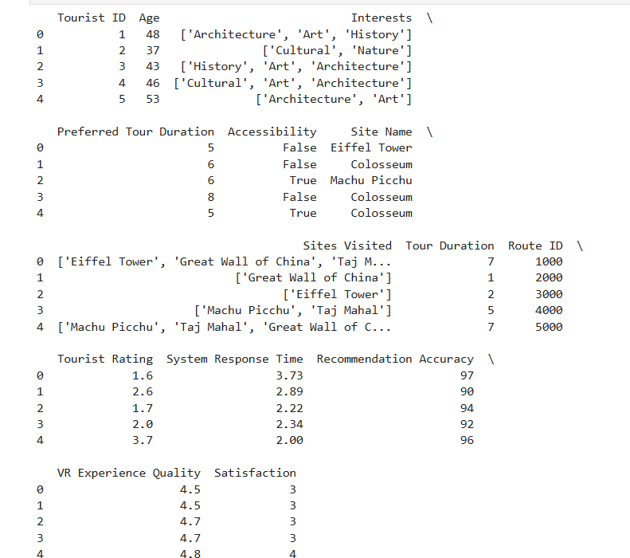
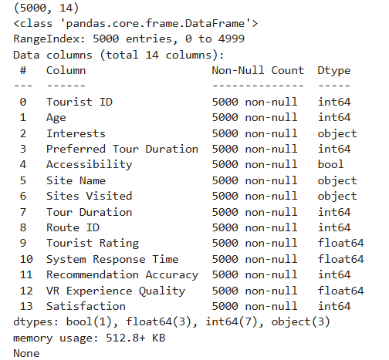

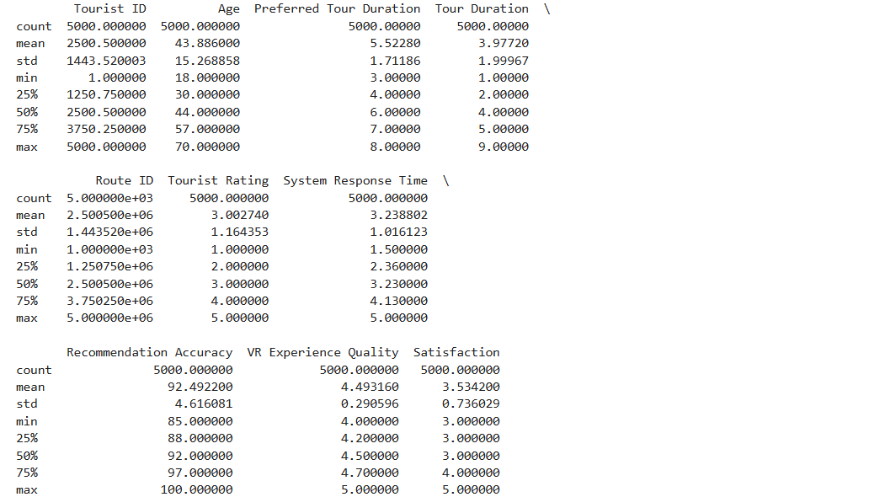

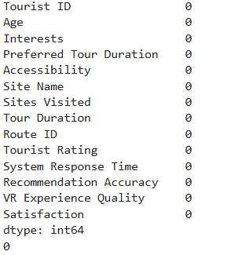
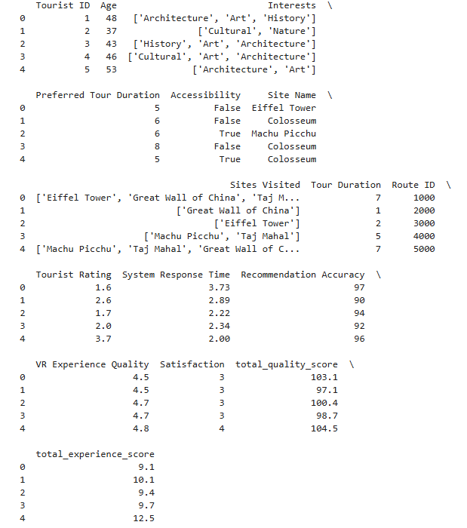

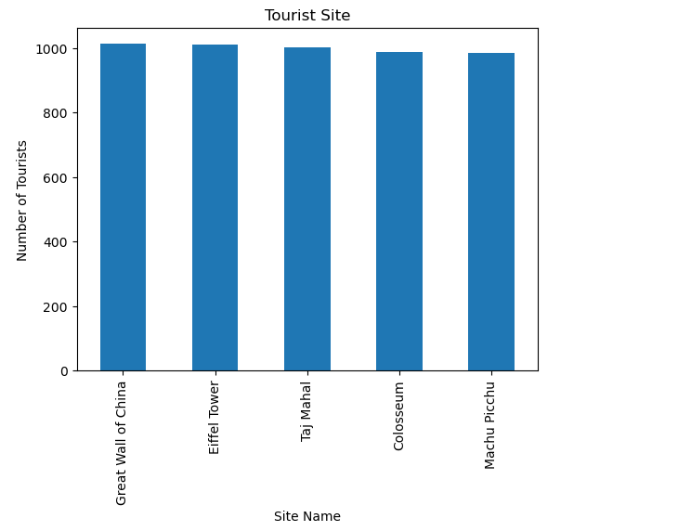

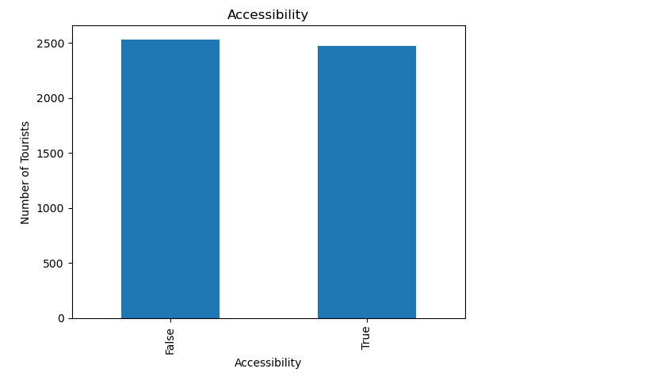

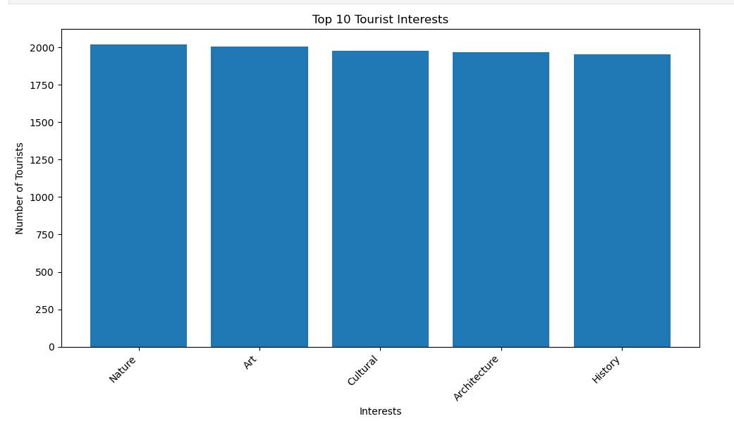
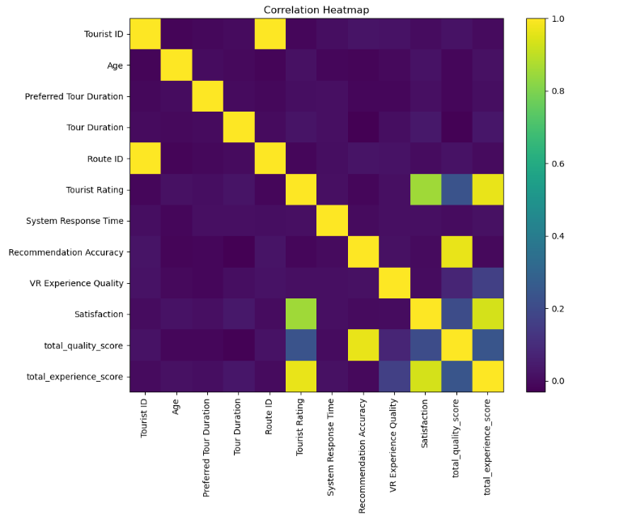

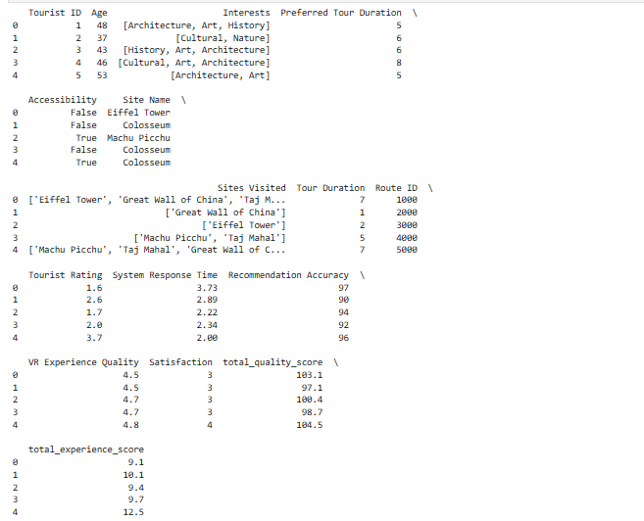

Result:

